# Software analysis and Design Case Study

# MSc Supervision Management System (MSMS)(D2)

**UML Use Cases diagram for MSMS**

The following diagram provides a visual representation of the key use cases in the MSc Supervision Management System (MSMS). It highlights the interactions between the system and the different actors involved, such as students, supervisors, course lead, IT staff and administrators, as they perform tasks within the system.

# UML Use cases diagram for MSMS

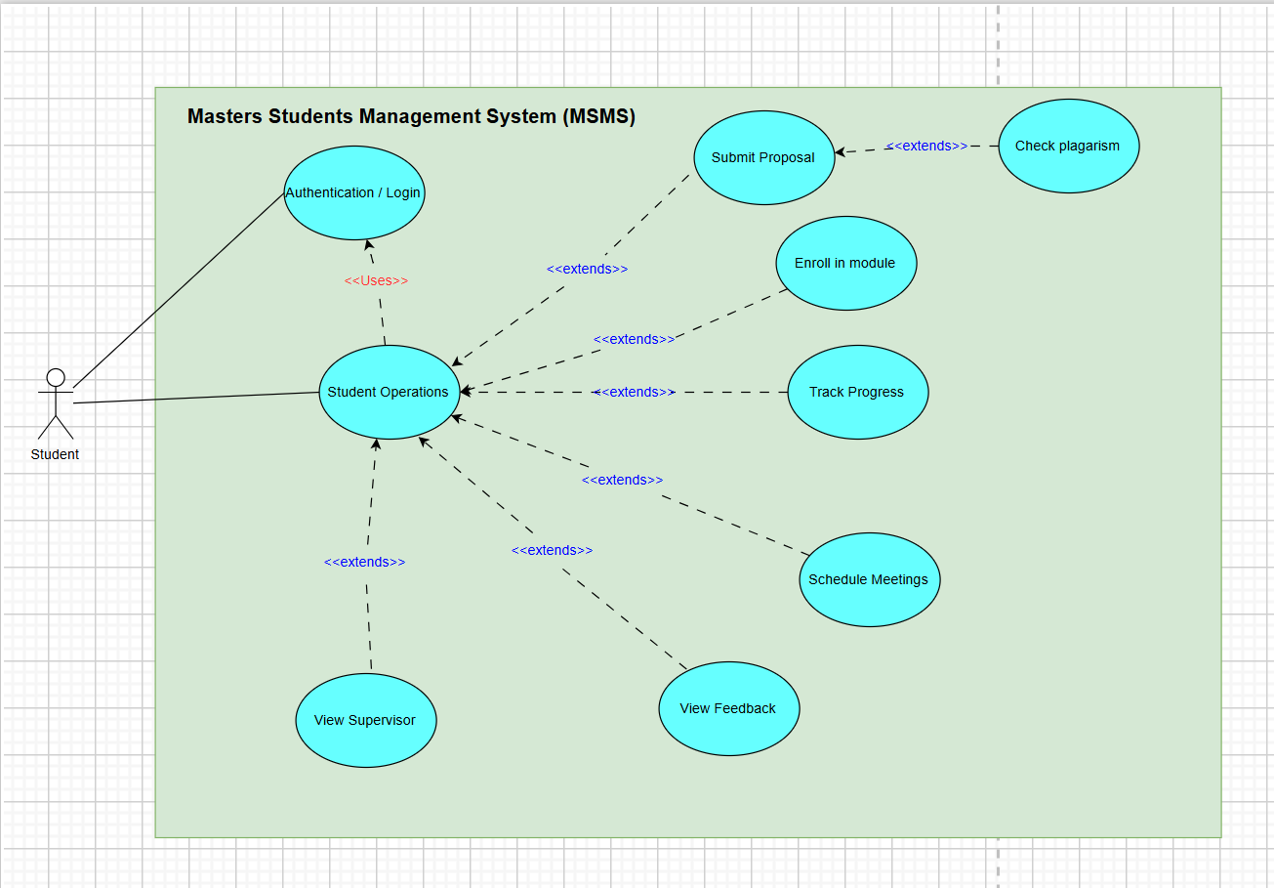

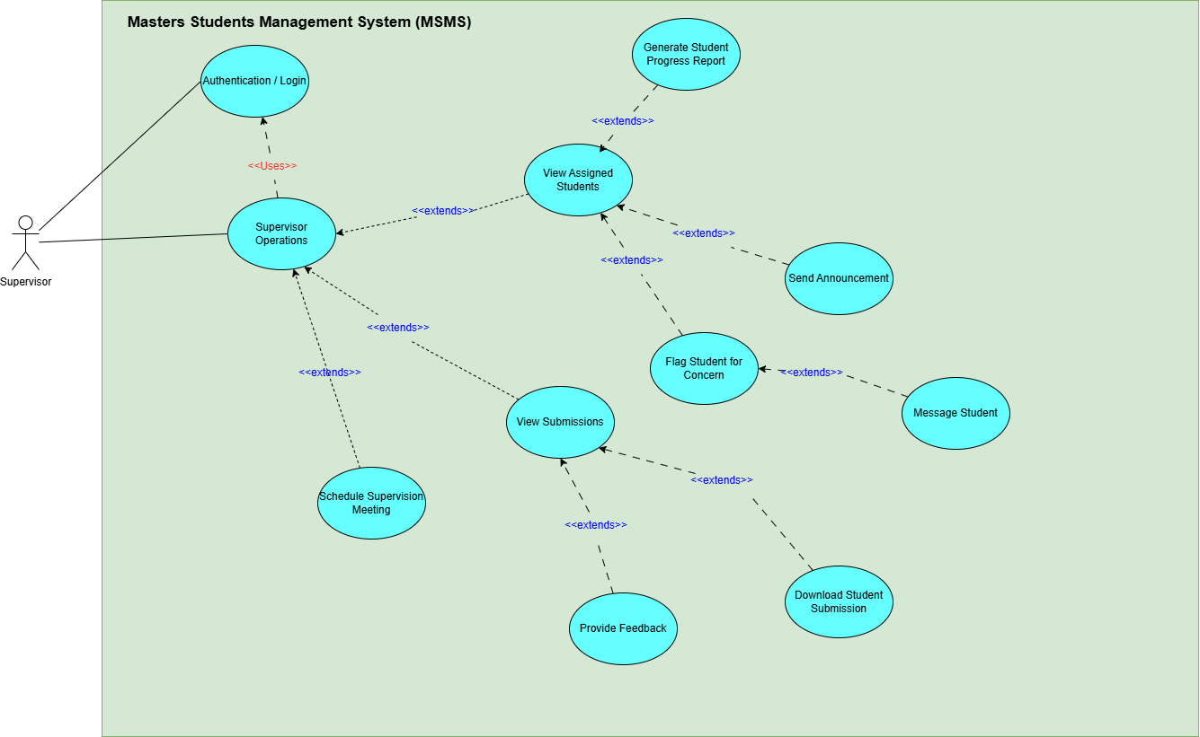

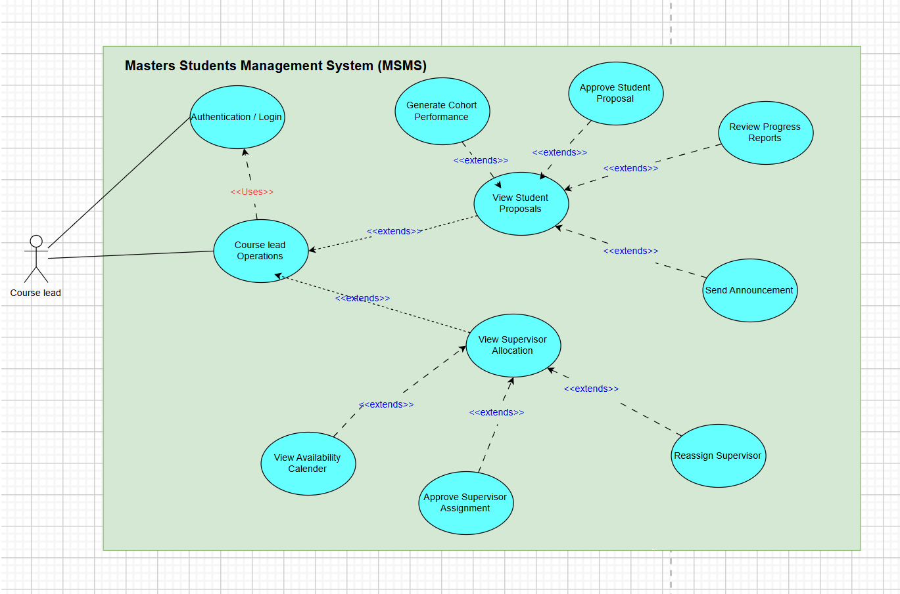

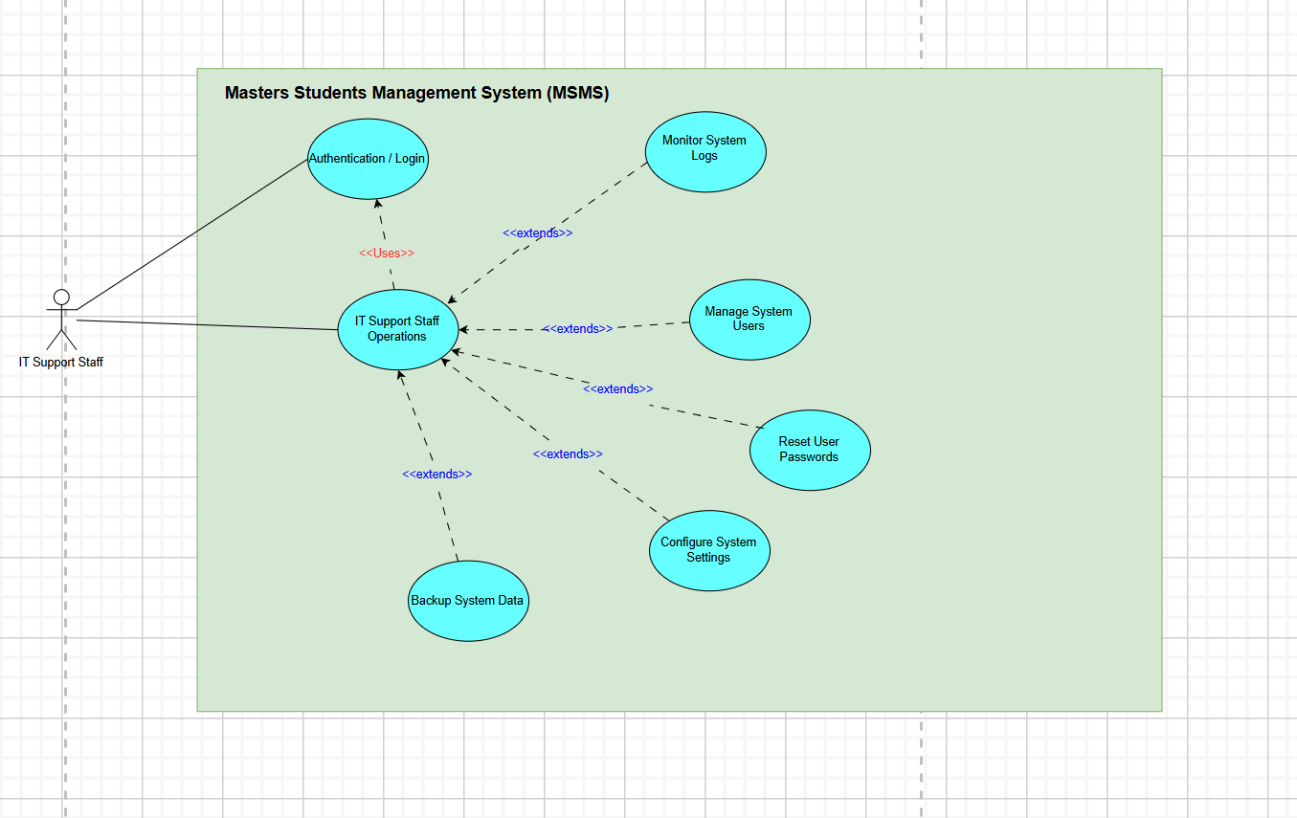

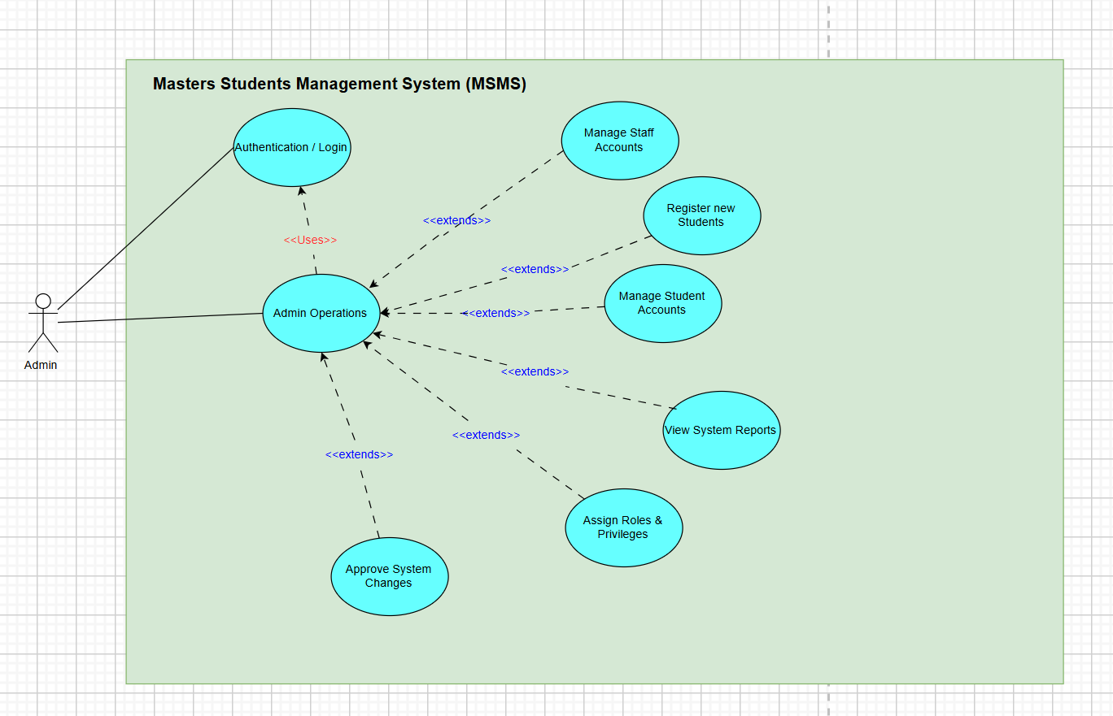

# Use Cases (Tables)

The following tables provide a detailed breakdown of each use case for the MSc Supervision Management System (MSMS). Each table outlines the purpose, actors involved, prerequisites, narrative flow, and possible alternative scenarios for key system functionalities, helping to further clarify the system’s operations and user interactions

## Use Case Table: Login

|  |  |
| --- | --- |
| Name | Login |
| Purpose | To allow authorized users to access their dashboard within the MSMS system. |
| Actor(s) | Student, Supervisor, Course Lead, IT Staff, Admin |
| Prerequisites | User must have registered credentials stored in the system. |
| Narrative | 1. The user navigates to the login interface. 2. The user enters username and password. 3. The system verifies credentials from the database. 4. Access is granted to the appropriate dashboard. |
| Outcome | User is logged into the MSMS system and redirected to their personalized dashboard. |
| Alternatively | User enters invalid login credentials. |
| Alternative Narrative | 1. System displays an error message indicating incorrect credentials. 2. User is prompted to retry login or reset password. |
| Outcome | User must enter valid credentials to proceed. |

## Use Case Table: Register and Create Account

|  |  |
| --- | --- |
| Name | Register and Create Account |
| Purpose | To register a new user (student, supervisor, etc.) into the MSMS system. |
| Actor(s) | Admin |
| Prerequisites | Admin must be logged into the system with appropriate privileges. |
| Narrative | 1. Admin selects 'Create New User.' 2. Admin inputs user details and assigns a role. 3. The system validates entries. 4. The user is created and credentials are saved. |
| Outcome | A new user account is registered and saved in the User database. |
| Alternatively | Entered data is incomplete or incorrect. |
| Alternative Narrative | 1. System alerts admin to missing or invalid fields. 2. Admin corrects entries and re-submits. 3. System saves valid data. |
| Outcome | Account creation is successful upon valid submission. |

## Use Case Table: Submit Project Proposal

|  |  |
| --- | --- |
| Name | Submit Project Proposal |
| Purpose | To allow a student to submit their research project proposal. |
| Actor(s) | Student |
| Prerequisites | Student must be logged in and have access to the submission module. |
| Narrative | 1. Student clicks 'Submit Proposal.' 2. Uploads proposal file and enters title/description. 3. System validates and stores the submission. |
| Outcome | Proposal is submitted successfully and logged in the system. |
| Alternatively | File format is invalid or missing fields. |
| Alternative Narrative | 1. System flags the issue and notifies the student. 2. Student re-uploads with corrections. 3. System accepts the valid submission. |
| Outcome | Proposal is saved upon valid input. |

## Use Case Table: Allocate Supervisor

|  |  |
| --- | --- |
| Name | Allocate Supervisor |
| Purpose | To allow course leads to assign supervisors to student projects. |
| Actor(s) | Course Lead |
| Prerequisites | Student must have a submitted and reviewed project. |
| Narrative | 1. Course Lead selects an unassigned student. 2. Chooses a suitable supervisor. 3. System links the supervisor and student. 4. Notifications are sent to both parties. |
| Outcome | Supervisor is assigned and allocation saved. |
| Alternatively | Supervisor is unavailable or overbooked. |
| Alternative Narrative | 1. System prevents allocation due to conflict. 2. Course Lead selects an alternative supervisor. 3. Allocation is completed successfully. |
| Outcome | Supervisor is assigned without conflict. |

## Use Case Table: Schedule Supervision Meeting

|  |  |
| --- | --- |
| Name | Schedule Supervision Meeting |
| Purpose | To allow students to book meetings with their assigned supervisor. |
| Actor(s) | Student, Supervisor |
| Prerequisites | Student must be assigned to a supervisor. |
| Narrative | 1. Student views supervisor availability. 2. Selects a time slot. 3. System logs meeting and notifies supervisor. |
| Outcome | Meeting is successfully scheduled. |
| Alternatively | Time slot is no longer available. |
| Alternative Narrative | 1. System displays an error. 2. Student selects a different time. 3. Meeting is booked. |
| Outcome | Meeting is logged successfully. |

## Use Case Table: Provide Feedback

|  |  |
| --- | --- |
| Name | Provide Feedback |
| Purpose | To allow supervisors to give feedback on student submissions. |
| Actor(s) | Supervisor |
| Prerequisites | Student must have made a submission. |
| Narrative | 1. Supervisor selects student submission. 2. Enters feedback text. 3. System saves feedback and notifies student. |
| Outcome | Feedback is stored and visible to the student. |
| Alternatively | Feedback field is left blank. |
| Alternative Narrative | 1. System alerts the supervisor. 2. Supervisor fills in the feedback. 3. Feedback is saved. |
| Outcome | Valid feedback is stored. |

## Use Case Table: Track Project Progress

|  |  |
| --- | --- |
| Name | Track Project Progress |
| Purpose | To allow students to monitor their research milestones and feedback. |
| Actor(s) | Student |
| Prerequisites | Student must be logged in and have an ongoing project. |
| Narrative | 1. Student clicks on 'Track Progress.' 2. System retrieves submission dates, milestones, feedback. 3. Displayed as a timeline or dashboard. |
| Outcome | Student can view all progress and pending tasks. |
| Alternatively | No data available yet. |
| Alternative Narrative | 1. System shows 'No submissions yet.' 2. Prompts student to make a submission. |
| Outcome | Student guided to start project workflow. |

## Use Case Table: Generate Supervision Report

|  |  |
| --- | --- |
| Name | Generate Supervision Report |
| Purpose | To allow course leads to generate analytics on supervision activities. |
| Actor(s) | Course Lead |
| Prerequisites | Data must exist for report type selected. |
| Narrative | 1. Course Lead selects report type. 2. System queries database and compiles data. 3. Report is displayed or downloadable. |
| Outcome | Report is generated and available. |
| Alternatively | No data exists for selection. |
| Alternative Narrative | 1. System alerts: 'No data available.' 2. Course Lead tries a different report type. |
| Outcome | Meaningful report is produced. |

## Use Case Table: Reset Password

|  |  |
| --- | --- |
| Name | Reset Password |
| Purpose | To allow IT staff to reset user credentials. |
| Actor(s) | IT Support |
| Prerequisites | User must exist in the system. |
| Narrative | 1. IT searches for user. 2. Clicks 'Reset Password.' 3. Enters new temporary password. 4. System saves and sends notification. |
| Outcome | User receives new login credentials. |
| Alternatively | User ID not found. |
| Alternative Narrative | 1. System displays error. 2. IT confirms user registration or creates a new one. |
| Outcome | User account is resolved. |

## Use Case Table: Upload Final Dissertation

|  |  |
| --- | --- |
| Name | Upload Final Dissertation |
| Purpose | To allow students to submit the final version of their research. |
| Actor(s) | Student |
| Prerequisites | Project must be approved and near completion. |
| Narrative | 1. Student uploads final document. 2. Adds abstract and keywords. 3. System validates format and stores file. |
| Outcome | Dissertation uploaded and archived. |
| Alternatively | File format is unsupported. |
| Alternative Narrative | 1. System alerts the student. 2. Student re-uploads correctly. 3. File is saved. |
| Outcome | Final dissertation is stored. |

## Use Case Table: Reassign Supervisor

|  |  |
| --- | --- |
| Name | Reassign Supervisor |
| Purpose | To allow course leads to change the supervisor for a student. |
| Actor(s) | Course Lead |
| Prerequisites | A supervisor must already be assigned. |
| Narrative | 1. Course Lead selects current allocation. 2. Removes current supervisor. 3. Assigns new supervisor. 4. System updates and sends notifications. |
| Outcome | Supervisor is changed. |
| Alternatively | New supervisor is unavailable. |
| Alternative Narrative | 1. System prevents reassignment. 2. Course Lead selects another candidate. |
| Outcome | Allocation completed successfully. |

## Use Case Table: View Notifications

|  |  |
| --- | --- |
| Name | View Notifications |
| Purpose | To allow users to view automated alerts and reminders. |
| Actor(s) | All Users |
| Prerequisites | User must be logged in. |
| Narrative | 1. User opens notification panel. 2. System fetches unread alerts. 3. Notifications are displayed. |
| Outcome | User views relevant updates. |
| Alternatively | No notifications available. |
| Alternative Narrative | 1. System shows 'No new notifications.' 2. User continues system usage. |
| Outcome | User stays informed. |

# Main Sequence Diagram for MSMS

The sequence diagram below illustrates the flow of interactions between the system's components for a specific process within the MSc Supervision Management System (MSMS). It details the sequence of events that occur when users engage with the system, helping to visualize how data and control flow between actors and the system during the execution of a particular use case.

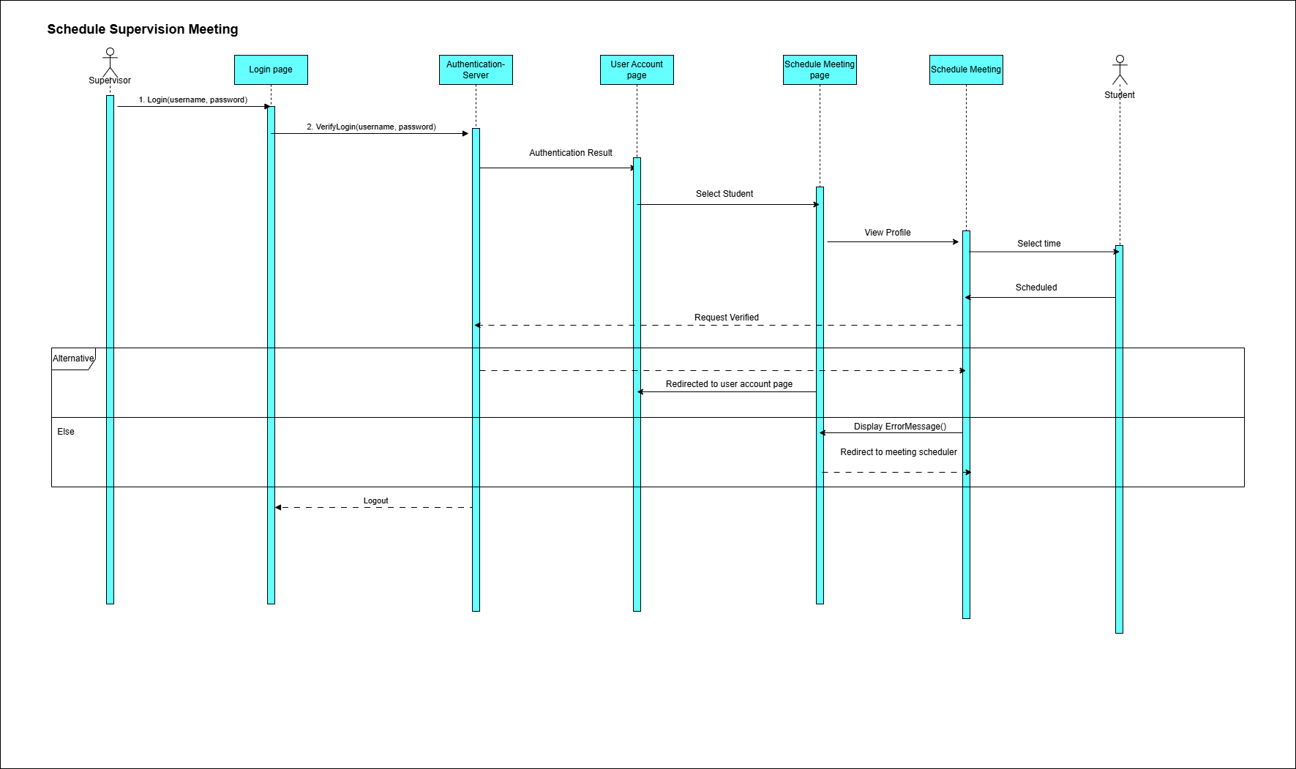

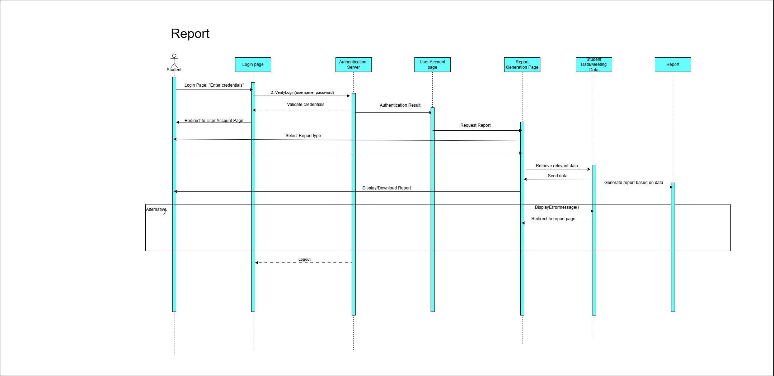

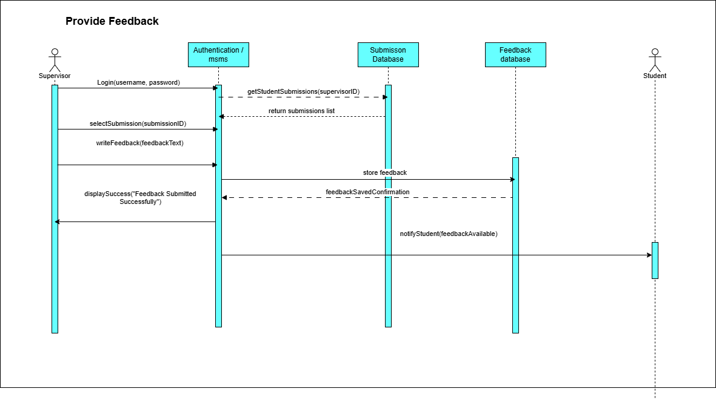

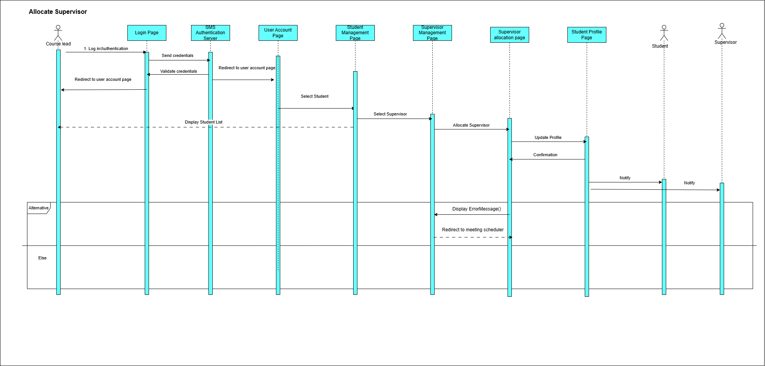

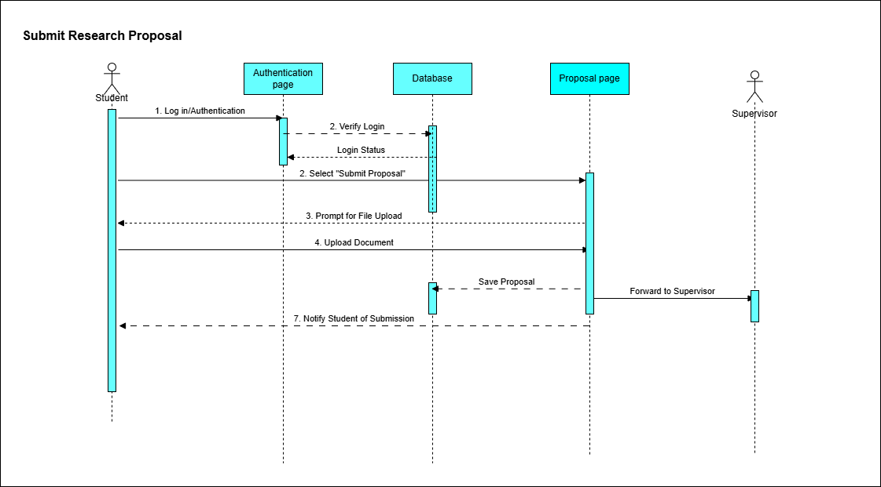

# ****Enriched Functional Requirement Table for MSMS****

|  |  |
| --- | --- |
| ID | Description |
| R1 | The MSMS system will support the supervision and tracking of postgraduate dissertation projects by automating project allocation, progress tracking, communication, and submission management. |
| R1.1 | The system will consist of a web-based application accessible to students, supervisors, course leads, and administrators through a secure login system. |
| R2 | Students and supervisors will be able to register and log in to the system using their university credentials. User roles will determine access to system features. |
| R3 | The system will allow students to submit their research project proposals and final dissertations. Each submission will be stored with version history. |
| R3.1 | Students will be able to view the status of each submission and receive automated updates when feedback or status changes occur. |
| R4 | Supervisors will have access to view student submissions, provide feedback, and track individual student progress over time. |
| R5 | Course leads will be able to automatically allocate supervisors to students based on specialization and supervisor availability. Manual reassignment will also be supported. |
| R5.1 | Allocation records will be stored for audit purposes and accessible in the system’s reporting module. |
| R6 | The system will include a scheduling tool that enables students and supervisors to set up virtual or in-person supervision meetings. |
| R6.1 | Meeting invitations will be integrated with institutional calendars, and both parties will receive automated reminders. |
| R7 | Supervisors will be able to provide feedback directly on submissions, and feedback history will be visible to both the student and course lead. |
| R8 | Students will be able to track their project milestones through a dedicated progress tracker dashboard, showing completed and pending stages. |
| R9 | The system will generate supervision and progress reports for course leads, including statistics on submission frequency, feedback timelines, and student progress ratings. |
| R10 | A notification system will send alerts to users regarding upcoming deadlines, meeting requests, feedback availability, and system announcements. |
| R11 | Supervisors and course leads will be able to export reports and feedback summaries as downloadable PDFs for record-keeping and audit purposes. |
| R12 | A secure messaging feature will allow supervisors and students to exchange direct messages related to their project, without relying on external email systems. |
| R13 | IT support users will have administrative access to manage user credentials, reset passwords, and monitor system logs for suspicious activity. |
| R14 | Students will have the option to request supervisor reassignment through a guided process involving course lead approval. |
| R15 | The system will maintain a full audit trail of user activities, submission timestamps, and feedback edits to support academic integrity and dispute resolution. |

# Enhanced Non-Functional Requirements Table for MSMS

|  |  |
| --- | --- |
| ID | Description |
| NFR1 | The system shall support a minimum of 50,000 concurrent users without performance degradation. Response times for key actions (e.g., file uploads, meeting scheduling, supervisor feedback) shall not exceed 2 seconds under normal conditions and 5 seconds during peak load (e.g., near submission deadlines). Load testing will be conducted quarterly to validate these thresholds. |
| NFR2 | The system shall comply with GDPR and institutional data protection regulations. All user data (students, supervisors, course leads) shall be stored securely using AES-256 encryption. Sessions shall automatically time out after 10 minutes of inactivity to prevent unauthorized access. |
| NFR2.1 | All failed login attempts shall be recorded and flagged after three consecutive failures, triggering an account lockout after five failures. The system shall implement role-based access control (RBAC) to restrict access to sensitive data based on user roles. |
| NFR3 | The system shall provide a user-friendly and intuitive interface. New users shall be able to perform key actions (submit proposals, schedule meetings, upload documents) with no more than 30 minutes of initial training. A tutorial or guided walkthrough will be embedded in the UI for first-time users. |
| NFR4 | The platform shall be maintainable and modular, supporting hotfixes and updates with zero or minimal downtime. IT support shall be able to push updates without disrupting ongoing user activities. The system will include error logging, traceability, and health monitoring to support incident resolution within 2 hours of detection. |
| NFR5 | All data shall be compliant with academic regulations and GDPR standards. Research documents, submissions, and communications must be retained for at least 5 years in secure archives. Access to these documents shall be strictly logged and auditable. |
| NFR6 | The system shall be optimized for performance efficiency, consuming no more than 5% CPU per active user session. Database queries shall return results within 3 seconds for 95% of users. Load balancing mechanisms will be used to handle large-scale traffic. |
| NFR7 | The system shall maintain 99.9% uptime annually, excluding pre-scheduled maintenance. Planned outages shall be announced 48 hours in advance, and in the event of failure, automatic failover shall occur within 5 minutes to minimize disruption. |
| NFR8 | The system shall support cross-device and cross-browser access, including full functionality on Chrome, Firefox, Edge, and mobile devices. Interface responsiveness shall be preserved with less than 10% feature deviation or distortion on screens smaller than 6 inches. |

# UML class diagram for the MSMS

The class diagram below provides a structural view of the MSc Supervision Management System (MSMS). It outlines the key classes within the system, their attributes, methods, and the relationships between them. This diagram helps to depict the system’s architecture and the internal structure that supports the various use cases and functionalities

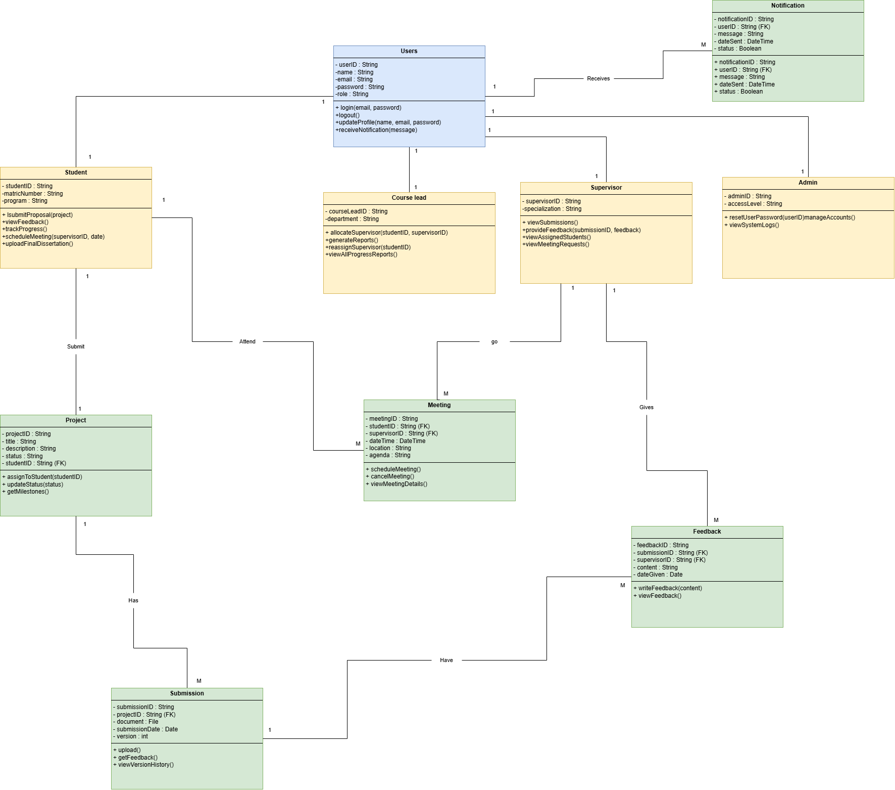

# Interfaces (Prototyping) for the MSMS

The following interface prototypes provide a visual representation of the user interface for the MSc Supervision Management System (MSMS). These prototypes demonstrate the layout and design of key screens, offering an early view of how users will interact with the system. They serve as a blueprint for the system's user experience and guide the development of the final user interface.

